诚信应考,考试作弊将带来严重后果！
_____________ ________
…

Name Student ID
( 密 封 线 内 不 答 题 )
……………………………………………………密………………………………………………封………………………………………线……………………………………线………………………………………

华南理工大学期末考试
《Discrete Mathematics》
note： 1. 考前请将密封线内填写清楚；
2. 所有答案请直接答在答题纸上；
3．考试形式：闭卷；
4. 本试卷共 4 大题，满分100分， 考试时间120分钟。

- Choose an answer to the following question. (10 x 2’ = 20’)
(1) Which is a proposition? ( )
A) Is the water boiling? B) x > 1.5
C) There will be no water on the earth after 5000 years. D) Help me.
(2) The implication is true for all possible assignments of truth values to p and q except for which assignment?( )
A）p false, q true B）p true, q false
C）p false, q false D）p true, q true
(3)Which of these statements is a correct translation of the statement: “No Computer Science Major is taking any courses” where C(x) is the statement x is a Computer Science Major, and T(x, y) is the statement x is taking y. Assume that the universe for x is the set of all students and the universe for y is the set of all courses. ( )
A） B）
C） D）
(4) Function  is defined as 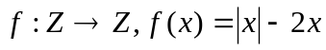, so is ( )
A）onto B） both onto and one-to-one
C）one-to-one D） neither onto nor one-to-one
(5) Supposed a binary relation R (Figure 1) on the set A = { 1, 2, 3 }, R is ( )
A) irreflexive, symmetric, non-transitive
B) reflexive, antisymmetric, transitive
3
2
1
C) irreflexive, antisymmetric, transitive
Figure 1. D) reflexive, antisymmetric, non-transitive

(6) Which of these arguments is true?( )
A) (P(S), subset of) is a poset and also total ordered

B) (Z+,|) is totally ordered

C) The divisibility relation(可整除) “ | ” is a partial ordering on the set of positive integers.(Z+,|) is a poset.

D) (N, >=) is well-ordered
(7) (A∪B)−C = ( )
A) (A – C) ∪ B B) (A−C)∪(B−C)
C) A – (B∪C) D) (A−C)∩(B−C)
(8) Which statement is correct? （ ）
A) There are 2n 1s and n (n-2) 0s in the adjacency matrix for Cn.
B) Cn is always bipartite
.

C) Qn has n2n edges and 2n vertices
.
D) Kn has n (n+1)/2 edges and n vertices
.

(9) How many planar graphs in the following graphs? ( )
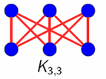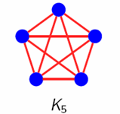
A) 4 B) 3 C) 2 D) 1
(10) Which statement is wrong? ( )
A. If a directed graph is strongly connected, it must be an Euler graph.
B. A graph with cut edge cannot be an Euler graph.
C. If a graph is an Euler graph, it must be a strongly connected graph.
D. A graph with cut vertex cannot be a Hamilton graph.

2． Fill in the blanks. (10 x 2’ = 20’)
(1) If p→q is true, the truth value of p∧q →q is
(2) Let C(x): x is a computer. D(x): x is a peripheral equipment. P(x, y): x can communicate with y. Express the sentence “some computers can’t communicate with some peripheral equipment” as a logical expression as______________.

(3) Let l be “Lois works late”, let j be “John works late”, and let e be “they will eat at home”. Express the statement “If Lois or John do not work late, then they will eat at home”
__________________
(4)A={ l，m，n }，B={ a，b，c }，C={ x，y，z }. R：A→B，S：B→C，and R={ <l，b>，<m，a >，<n，c> }, S={< a，y>，<b，x> ，<c，y>，<c，z>}， SоR =______________.
(5) A = { ∅, {∅}}, 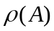 is the power set of A. =______________.
(6)  is the real number domain. For 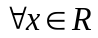, 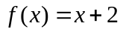, 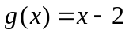 and 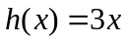. Hence, 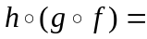 _______________.
(7) R is “ more than or equal to” relation on Z×Z，then R⁻¹=________.
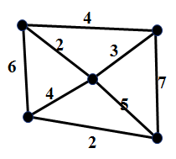
(8)  is the relation “brother or sister”, 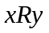 represents “ is the brother or sister of ”, ① irreflexive ② reflexive ③ symmetric ④ antisymmetric ⑤ transitive. has the properties _____.
(9) The complete bipartite graph K_{m, n} has ____ cut edges.
(10) The sum of the weights of the minimum spanning tree for the graph in the right hand side is _____.

- Computation and Analysis. (6 x 6’ = 36’)
- Prove the equivalence of predicate:

- Given the premises ¬A∨B, ¬C→¬B, C→D, how to get the conclusion A→D?

- Suppose A = {a , b, c, d}, a relation on A is R = {<a, b>, <b, a>, <b, c>, <c, d>}.
Please use the zero-one matrix to find the transitive closure of R.
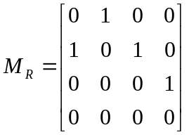

- Can the following graph be drawn in one stroke ? Why ?
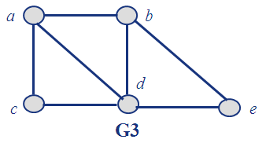

(5) Find out whether G and H are isomorphic. No matter what the judgment is, please give your explanation and argument.
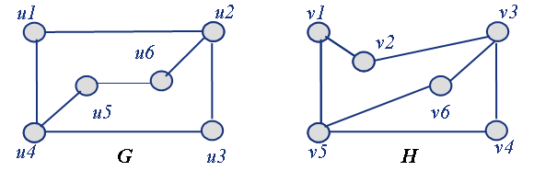

(6) Use the ordered rooted tree to represent the expression ((3*x-5*(y↑2))↑5)/(a*((b↑3)-4*c))

- Application of Discrete Mathematics. (4 x 6’ = 30’)
- Use inference to obtain conclusion from the premises.
All the people who like walking do not like driving. Every person likes driving or riding. Some people don’t like riding. Therefore, some people don’t like walking.

(2)Suppose R is a reflexive and transitive relation on A. T is also a relation on A, such that:
<a，b>∈T⇔<a，b>∈R and <b，a>∈R
Prove that T is an equivalence relation.

(3) 6 people are supposed to accomplish 3 tasks in groups (2 people in one group). The people in the same group should cooperate with each other to accomplish the task. We now know each person could cooperate with at least other 3 people. Is that possible that all the tasks could be accomplished?

(4) The roads represented by this graph are all unpaved. The lengths of the roads between pairs of towns are represented by edge weights. Which roads should be paved so that there is path of paved roads between each pair of town so that a minimum road length is paved?

